**Bug report Redtag**

**ID:** Bryheda_1_ Redtag

**Summary**: Ukrainian words in the validation messages of the General Application form when invalid data input (on the main page and ones Services, Portfolio, About Us, Blog, Events, Careers, Unbroken)

**Severity**: Minor **Priority**: Low

**Environment:** Opera version 96.0.4693.80

**Pre-conditions**:

* Open the website <https://www.redtag.pro>

**Steps to reproduce**:

1. Scroll down to the General Application form.
2. When the empty form fields “Hey, my name is”, “Contact me here” and un-selected value in the dropdown “and I'm looking for” click the “Send” button.
3. Pay attention to the validation message in Ukrainian "Заповніть це поле." under the “type here” placeholder.
4. Fill the form fields “Hey, my name is” with valid input (“Valentyna Bryheda”) and click the “Send” button.
5. Pay attention to the validation message in Ukrainian "Виберіть елемент зі списку." under the dropdown “and I'm looking for”.
6. Select “Project implementation” in the dropdown “and I'm looking for” (or any other valid value) and click “Send” button.
7. Pay attention to the validation message in Ukrainian "Заповніть це поле." under the “your email here” placeholder.
8. Fill the form field “Contact me here” with invalid data “1” and click the “Send” button.
9. Pay attention to the validation message in Ukrainian "Електронна адреса має містити знак "@". В електронній адресі "1" знака "@" немає" under the “your email here” placeholder.
10. Fill the form field “Contact me here” with invalid data “@”and click the “Send” button.
11. Pay attention to the validation message in Ukrainian "Введіть частину електронної адреси до знака "@". Електронна адреса "@" неповна." under the “your email here” placeholder.
12. Fill the form field “Contact me here” with invalid data “1@” and click the “Send” button.
13. Pay attention to the validation message in Ukrainian "Введіть частину електронної адреси після знака "@". Електронна адреса "@" неповна." under the “your email here” placeholder.

**Comment:**

The same for the General Application form on pages Services, Portfolio, About Us, Blog, Events, Careers, Unbroken.

✅ **Expected Result**:

The site contains English text.

❌ **Actual Result**:

In the General Application form shows validation messages in Ukrainian when invalid data input.

**➕ Attachments**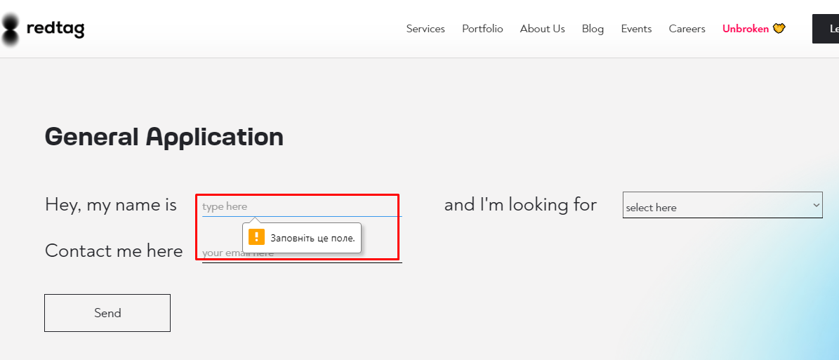

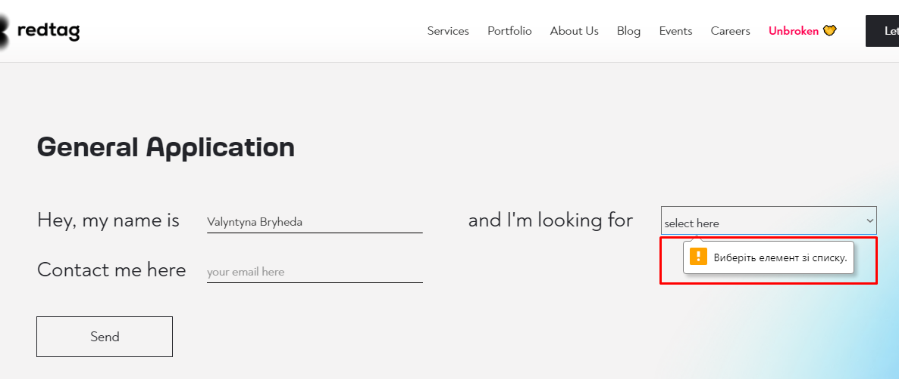

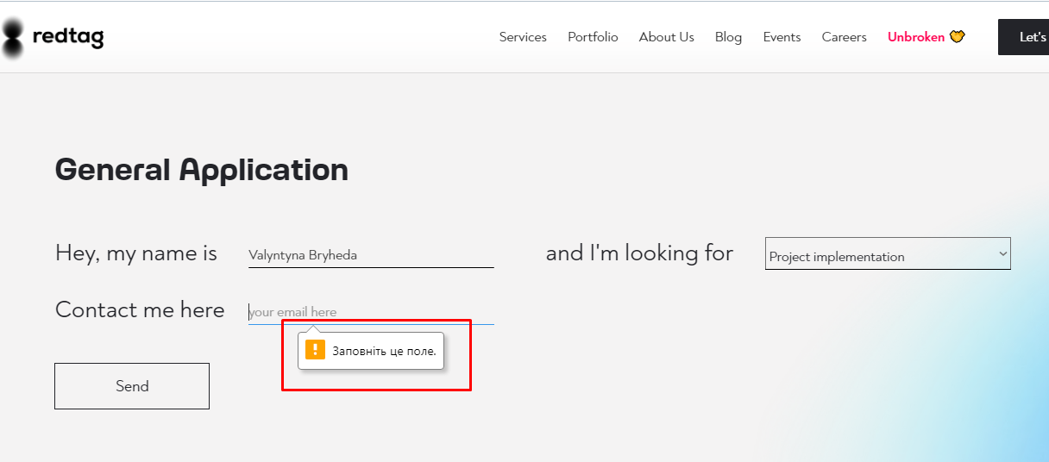

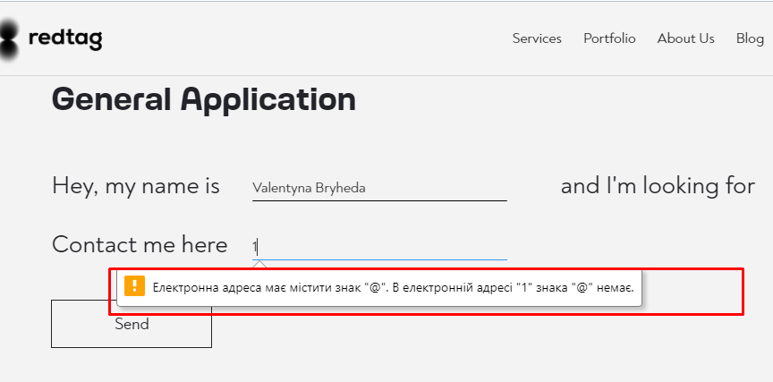

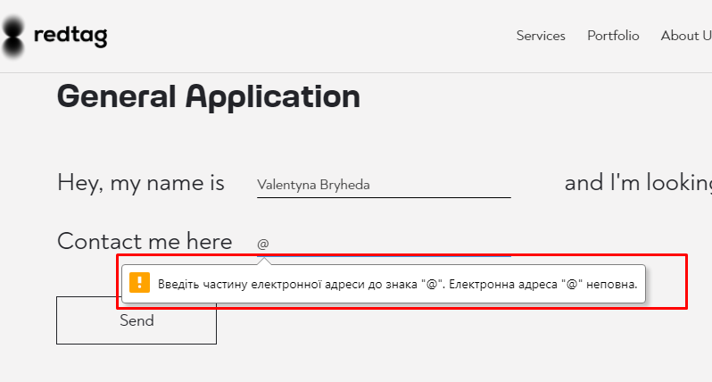

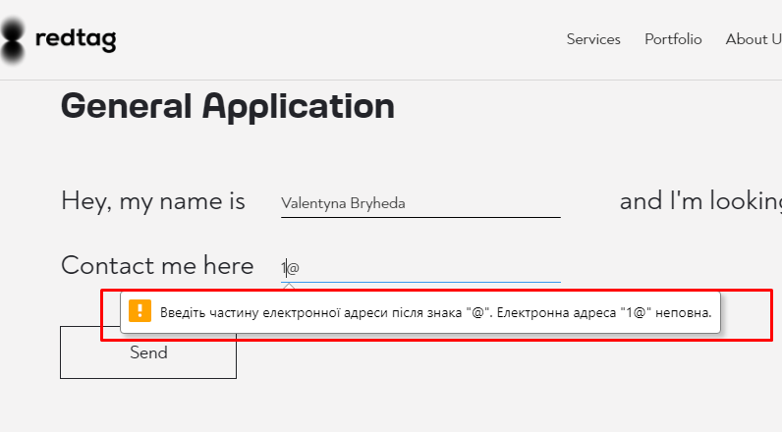

**Bug report Redtag**

**ID:** Bryheda_2_ Redtag

**Summary**: Submission sending from the General Application form with invalid e-mail (“1@1”) is an available (on the main page and ones Services, Portfolio, About Us, Blog, Events, Careers, Unbroken)

**Severity**: Minor **Priority**: Low

**Environment:** Opera version 96.0.4693.80

**Pre-conditions**:

* Open the website <https://www.redtag.pro>

**Steps to reproduce**:

1. Scroll down to the General Application form.
2. Select “Project implementation” in the dropdown “and I'm looking for” (or any other valid value), fill the form field “Hey, my name is” with valid data (“Valentyna Bryheda”) and the field “Contact me here” with invalid data “1@1”
3. Click the “Send” button.
4. Pay attention that submission is sending when the e-mail is invalid.

**Comment:**

The same for the General Application form on pages Services, Portfolio, About Us, Blog, Events, Careers, Unbroken.

✅ **Expected Result**:

The submission from the General Application form is not sending when the data input is invalid.

❌ **Actual Result**:

The submission is sending when the e-mail is invalid.

**➕ Attachments**